English IV
Summer Reading 2022

IB SL Literature & Language
The House of Spirits by Isabel Allende
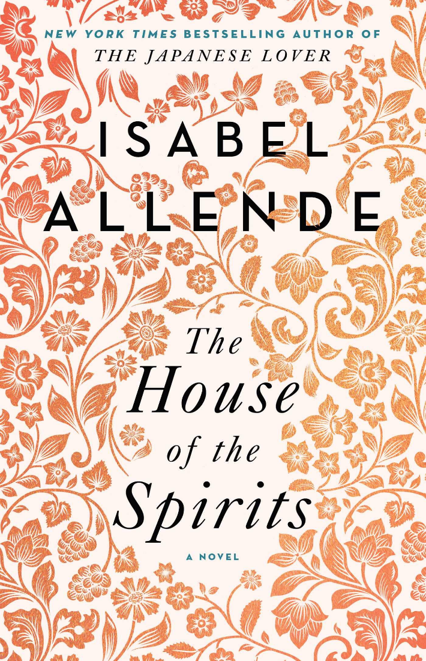

IB HL Literature & Language Year 2 / Dual Enrollment
Isabel Allende student choice:
- House of Spirits
- Paula
- City of Beasts
- Ines of my Soul
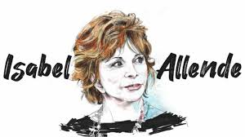

IB HL Literature & Language Year 2 / Dual Enrollment: Intro to Literature & British Literature

Extremely Loud & Incredibly Close by Jonathan Safron Foer

