English III
Summer Reading 2022

Pre-IB English III
The House of the Scorpion by Nancy Farmer
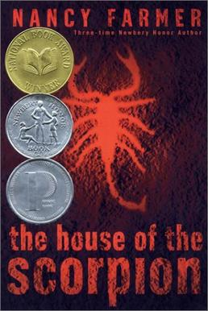

IB HL Literature & Language Year 1
Gabriel Garcia Marquez student choice:
- 100 Years of Solitude
- Chronicles of a Death Foretold OR
- Collected Stories (This is the title of the book—students should read all stories in the collection)
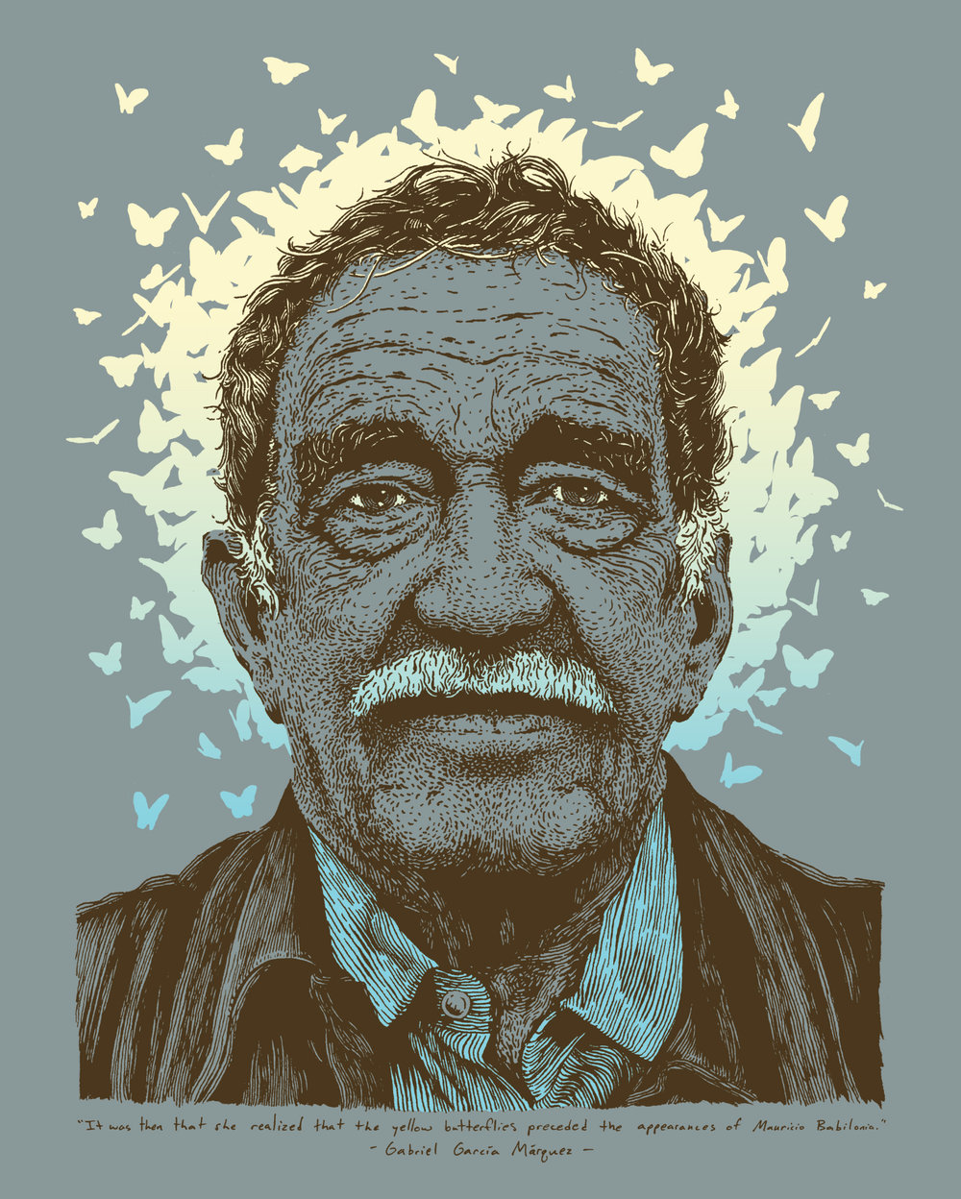
IB HL Dual Enrollment Year 1: Rhetoric and Composition I & II
Persepolis by Marjane Satrapi
